Kentucky Prescribed Fire Council Certified Burn Boss Workshop Application
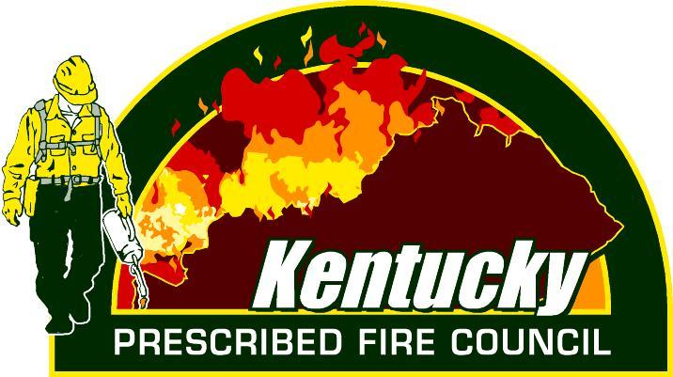

The KPFC will host a Certified Burn Boss Workshop February 4-7, 2020 at Bernheim Research Forest in Clermont, Kentucky. Cost will be $200 plus food and lodging. Space is limited so interested participants need to apply by completing the information below. All applications must be submitted no later than December 13, 2019. Student selections will be announced by December 20th. Selected students will be notified by email.

Name:________________________________
Affiliation:___________________________________________
Email:_____________________________ Phone:_____________________

Participation in the Certified Burn Boss Workshop requires that students meet certain prerequisites including NWCG coursework listed below and participation on a minimum of 5 prescribed fires or wildfires.
Please indicate which NWCG classes you have completed or will complete prior to the workshop. Use blank space to list additional fire trainings that you have successfully completed:
__L-180
__I-100
__S-130
__S-190
*Must include copy of certificates showing course completion with application

Please provide the information below documenting participation on 5 fires:
Prescribed or Wildfire | Date | Location  (County) | Acres of burn unit | Job duties on fire | Name of Burn Boss | Signature of Burn Boss or current Supervisor  (signature verifies participation)

By signing I certify that the information listed in the table above is true and accurate to the best of my knowledge.

Signature:____________________________________________ Date:____________________

Please submit application and supporting documentation to Jacob.Stewart@ky.gov no later than December 1, 2019

