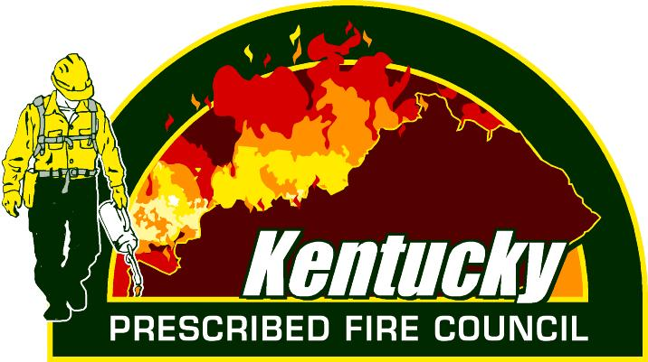
Kentucky Prescribed Fire Council
2022 Annual Meeting - Virtual
May 17th, 2022

(All times EST)
10:00-10:05 Welcome
10:05-10:30 Fire Season updates
10:30-11:15 Dr. Gregory Frey (USFS): Comparing regulations and incentives across states within the Appalachian region and discussing Rx fire trends.
11:15-12:00 Dr. Michael Saunders (Purdue University): Evaluating Economic Impacts of Prescribed Fire in the Central Hardwood Region.
12:00-1:00 Lunch
1:00-1:30 Ryle Benke (USFS): Helicopter and Unmanned Aircraft Ignitions.
1:45-2:30 Chris Minor (TNC) and Steve Simon – An Overview of Ecological Zone Modeling in the Central Appalachians of Kentucky
2:30-3:00 KYPFC Committee Updates
3:00-3:15 Board Elections and Close-out

