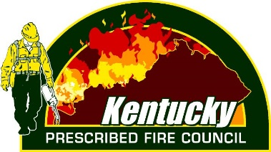
Certified Burn Boss Workshop Agenda
February 2 – 4, 2021
Hybrid Training via Zoom Video Conference
(All times Eastern Time Zone)
Pre-work, before February 2
Unit 1: Fire in Kentucky – pre-recorded TBD
Unit 2: Burn Plan Development – pre-recorded portion Cody Rhoden, Kentucky Department of Fish & Wildlife Resources
Tuesday, February 2
7:45 – 8:00am Welcome & Course Overview

8:00 – 8:30am Unit 2: Burn Plan Development (Pre work questions review) –
Ben Robinson/Cody Rhoden, Kentucky Department of Fish & Wildlife Resources
8:30 – 9:20 am Unit 3: Fire Weather – Rick Caldwell, Bernheim Arboretum and Research Forest
9:20 – 10:00am Break
10:00 – 10:50am Unit 4: Smoke Management – TBD
10:50 – 11:00am Break
11:10 – 12:00pm Unit 5: Fire Behavior – Tom Edwards, Kentucky Department of Fish & Wildlife Resources
12:00 – 1:30pm Lunch
1:30 – 2:20pm Unit 6: Ignition Techniques – Jake Royse – US Forest Service
2:20 -3:00pm Break
3:00 – 3:50pm Unit 7: Holding and Contingency Planning – TBD
Wednesday, February 3
Field Day
Locations:
Grayson Lake WMA Bernheim Forest
Frankfort (KDFWR headquarters) Berea College
Pennyrile State Forest Peabody WMA

8:00-12:00pm Field Session & Forest Burn Plan Development
12:00 – 1:00pm Lunch (bring lunch to eat in field)
1:00 – 5:00pm Field Session & Grassland Burn Plan Development

Thursday, February 4
8:00 – 9:00am Unit 8: Controlled Burn Safety – Michael Schuerman
9:00 – 9:15am Break
9:15 – 10:15am Unit 9: Kentucky Fire Season & Air Quality Regulations – Strider Deaver, KY Division of Forestry
10:15 – 10:30am Break
10:30 – 11:30am Unit 10: Implementing the Controlled Burn – Jacob Stewart, Kentucky Department of Fish & Wildlife Resources
11:30 – 12:45pm Lunch
12:45 – 2:45pm Group Discussion: Crew Briefing Exercise
2:00 – 3:30pm Closing Remarks/Moving Forward – TBD

