Kentucky Prescribed Fire Council Certified Burn Boss Workshop Application
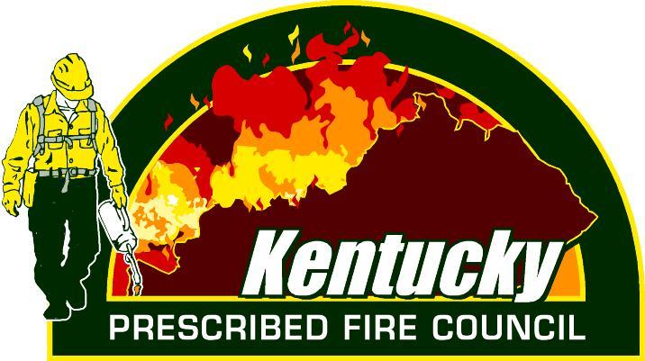

The KPFC will host a Certified Burn Boss Workshop February 2-4, 2021 at as a hybrid course. Students will be required to attend all virtual (Zoom/Teams) sessions that will take place on February 2nd & 4th, as well as the in person field day that will take place on February 3rd. The council will have 6 field locations across the state for you to choose from. Each location will be limited to 6 students and 2 instructors. Cost will be $200. Space is limited so interested participants need to apply by completing the information below. All applications must be submitted no later than December 18th 2020. Student selections will be announced by January 6th 2021. Selected students will be notified by email. The field locations are subject to change (reduced number of locations) due to CoVid-19 and number of applicants.
Name:________________________________
Affiliation:___________________________________________
Email:_____________________________ Phone:_____________________
Participation in the Certified Burn Boss Workshop requires that students meet certain prerequisites including NWCG coursework listed below and participation on a minimum of 5 prescribed fires or wildfires.
Please indicate which NWCG classes you have completed or will complete prior to the workshop. Use blank space to list additional fire trainings that you have successfully completed:
__L-180
__I-100
__S-130
__S-190
*Must include copy of certificates showing course completion with application

Please provide the information below documenting participation on 5 fires:
Prescribed or Wildfire | Date | Location  (County) | Acres of burn unit | Job duties on fire | Name of Burn Boss | Signature of Burn Boss or current Supervisor  (signature verifies participation)

By signing I certify that the information listed in the table above is true and accurate to the best of my knowledge.

Signature:____________________________________________ Date:____________________

Please submit application and supporting documentation to Cody.Rhoden@ky.gov no later than December 18th 2020.

Kentucky Prescribed Fire Council Certified Burn Boss Workshop Field Day Location

Each Student will be required to attend a field day at one of the below locations on February 3rd, 2021. Please rank each location with 1 being your most preferred site and 6 being your least preferred. If you are chosen for the course you will be receive your field day location with your acceptance letter. Field day locations are subject to change.

Locations:
_____ Grayson Lake WMA _____ Bernheim Forest
_____ Frankfort (KDFWR headquarters) _____ Berea College
_____ Pennyrile State Forest _____ Peabody WMA

